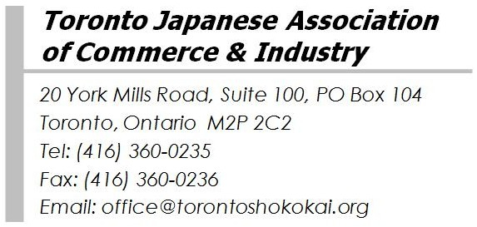
SHOKOKAI 60th Anniversary・2017 New Year's Reception

Toronto Japanese Association of Commerce and Industry (called Shokokai) commemorate its 60th anniversary of establishment in 2017. I would like to express my appreciation on behalf of board members that it is all because of the result of the unified support and cooperation of member companies and Japanese communities in Toronto.
As a Japanese business association to contribute to the development of economic exchange between Japan and Canada and to raise its presence as well as expand its activities, I am pleased to invite you to the 60th Anniversary・2017 New Year’s Reception which will be held on Friday, January 20, 2017.
We expect over 200 members and their partners and colleagues gathering at this time to have a New Year celebration with a wonderful seated dinner and a lucky draw. We look forward to celebrating this special moment with you and guests giving us continuous support for economic relations between Japan and Canada.

Date: Friday, January 20, 2017
Time: 5pm Registration & Cocktails / 6:30pm Opening / 9pm Closing
Place: Toronto Don Valley Hotel and Suites - Commonwealth Ballroom
175 Wynford Drive, Toronto, Ontario M3C 1J3
Tel: (416) 449-4111
Fee: $100 per person for non-members
(Includes HST, Dinner, Drinks, Coat check, parking fee and $10 Donation)
*Note: $10 donation will be donated to two TDSB schools where the Japanese School of Toronto Shokokai Inc (Hoshuko) uses their school facilities on Saturday.
Registration: Please email or fax the application form on the next page no later than Tuesday, January 10, 2017
*If you do not receive a confirmation email after you send registration within one week, please contact the Shokokai office.
*We cannot refund the fees for any reasons after January 10.

For any questions, please contact the Shokokai Office at any time. We look forward to seeing you at our 2017 New Year’s Reception.

Best Regards,

Toshiaki Maruoka
President
Toronto Japanese Association of Commerce and Industry

Please E-Mail or Fax to: Toronto Shokokai

E-Mail: office@torontoshokokai.org Fax: (416) 360-0236
20 York Mills Road, Suite 100, PO Box 104, Toronto, ON, M2P 2C2
60周年記念・2017年度新年懇親会出席申込表
60th Anniversary・2017 New Year’s Reception (Friday, January 20, 2017)
1月10日（火）までにEメールまたはFAXにてお申し込みください。
Please register with this form by e-mail or fax by Tuesday, January 10, 2017.

Company name
Contact name
E-mail address

Mr./Mrs./Ms. | Given Name | Sir Name | Note
※座席は指定席となりますが、特にご希望がある場合はその旨をご記入下さい。
All seats are reserved. Please specify if you have special seating requests.
※アレルギーのある方や、魚のメイン及びベジタリアンメニューをご希望される場合はその旨ご記入下さい。
Please specify if you have any dietary restrictions, or if you will select the fish main dish or the vegetarian course.

 | Fee /person |  | Number of Attendees |  | Total (CAD$)
商工会会員以外 (Non-members) | $100 | X |  | =

【参加費お支払につきまして / For Payment】
お申込み後、以下の通り、小切手、銀行送金、e-transferのいずれかにて1月19日（木）までに、商工会事務局へお支払いください。
Please make a payment either by cheque, EFT or e-transfer to the Shokokai no later than Thursday, January 19, 2017.

<Cheque payment> Please mail a cheque with a copy of this form to the address below.
Payable to: Toronto Japanese Association of Commerce & Industry
Mailing Address: 20 York Mills Road, Suite 100, PO Box 104, Toronto, ON, M2P 2C2

<EFT and e-transfer payment> Please ask the Shokokai office for details.

